MODHSS
U = U Campaign

Social Graphic 1:
Caption: Antiretroviral Therapy, or ART, can help you achieve viral suppression if you’re living with HIV. And getting closer to undetectable means untransmittable, keeping you and the ones you love healthy.
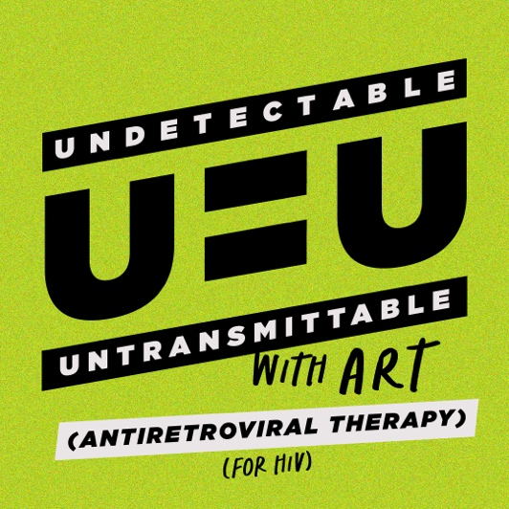
Headline: Start Your Journey
Call to Action: Learn More

Social Graphic 2:
Caption: An HIV diagnosis doesn’t define you. Antiretroviral Therapy, or ART, can get you closer to undetectable AND untransmittable, meaning HIV can’t be spread, and it’s more accessible than ever!
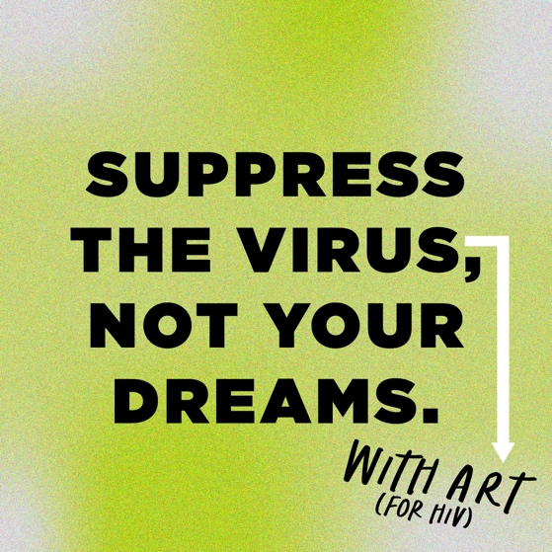
Headline: Do it for You
Call to Action: Learn More

Social Graphic 3:
Caption: Take the first step to a healthy life with HIV. Get in care and talk to your provider about Antiretroviral Therapy.
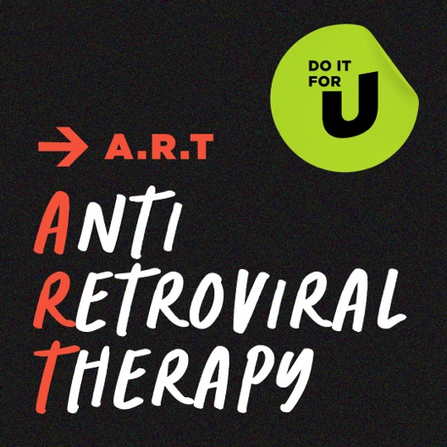
Headline: Achieve Viral Suppression
Call to Action: Learn More

For the social videos, we recommend keeping the captions VERY short. The following are simply screenshots of the videos you have seen.

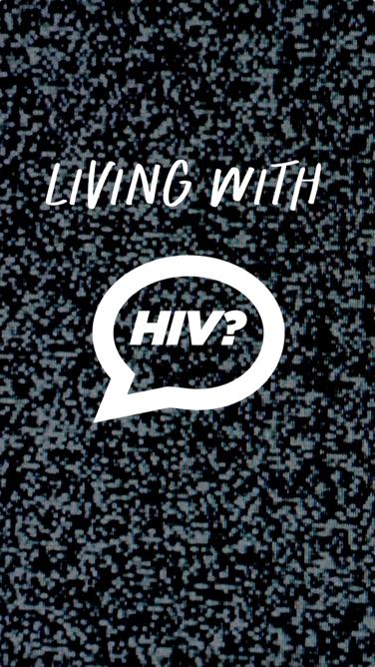
Caption: Achieve viral suppression with Antiretroviral Therapy.
Call to Action: Learn More

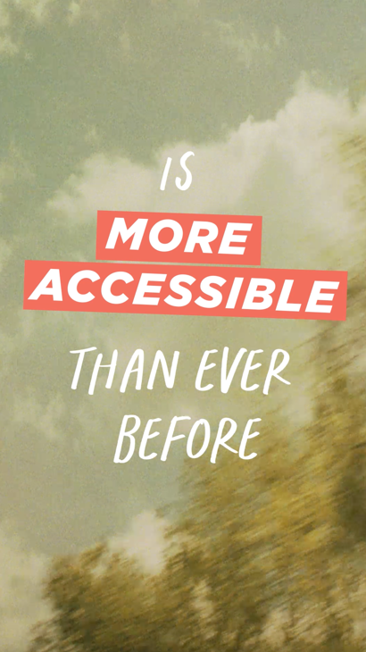
Caption: Antiretroviral Therapy helps you live healthy.
Call to Action: Learn More

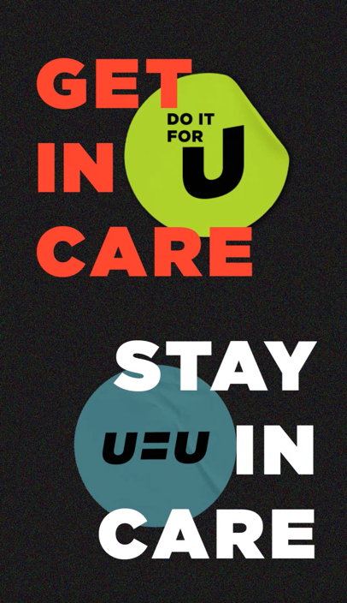
Caption: Get closer to undetectable and untransmittable.
Call to Action: Learn More

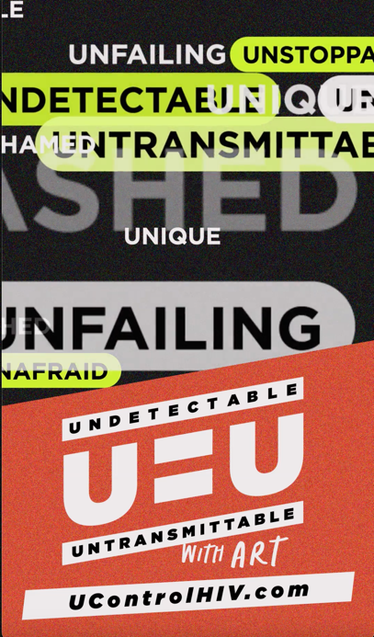
Caption: An HIV diagnosis doesn’t define you.
Call to Action: Learn More

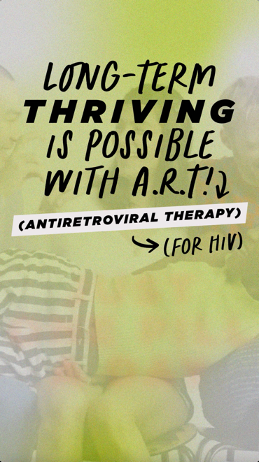
Caption: Start your HIV medical care journey!
Call to Action: Learn More

